Watershed and oceanic controls on spatial and temporal patterns of sediment accumulation in a fringing coral reef embayment: Faga'alu Bay, American Samoa

by

Messina, A.M.1*, Biggs, T.W.1, Storlazzi, C.D.2

1 San Diego State University, Department of Geography, San Diego, CA 92182, amessina@rohan.sdsu.edu, +1-619-594-5437, tbiggs@mail.sdsu.edu, +1-619-594-0902

2 US Geological Survey, Pacific Coastal and Marine Science Center, Santa Cruz, CA 95060, cstorlazzi@usgs.gov, +1-831-460-7521, ocheriton@usgs.gov, +1-831-460-7579

# Abstract

Anthropogenic watershed disturbance has increased sediment stress on many coral reefs, and integrated ridge-to-reef understanding of sediment dynamics is needed to support coral conservation. Sediment accumulation on flat-surfaced sediment pods and in tubular sediment traps was monitored quasi-monthly at 9 sites in Faga’alu Bay, American Samoa, over a one-year period and related to suspended sediment yield from the adjacent watershed, wave heights, benthic sediment composition, and water circulation patterns in the small, coral reef-fringed embayment. Similar to other studies, sediment pods measured an order of magnitude less sediment accumulation than sediment traps. Sediment accumulated in traps was predominantly carbonate and generally reflected the composition of surrounding benthic sediment at each site, though sediment on the north reef was characterized by a higher terrigenous fraction compared to the surrounding seabed, suggesting enrichment by terrigenous sediment discharged from the stream during storm events. Terrigenous sediment accumulation in the sediment trap nearest the stream outlet was significantly correlated (*p*<0.05) with suspended sediment yield from the stream, but not at sites on the reef flat, suggesting accumulation was dominated by fluvial processes only near the stream outlet. Sediment accumulation rates in sediment traps on parts of the reef flat and on the fore reef were significantly correlated with mean wave heights during deployments, suggesting wave-driven resuspension of reef-derived sediment was the dominant source of sediment accumulation in those areas. Sediment accumulation on sediment pods, however, was negatively correlated with wave heights in a few locations, suggesting any accumulated sediment from resuspension was removed by advection and residence time was low. Average sediment accumulation on sediment pods and in sediment traps exceeded literature values for coral health impact thresholds in some collections, near the stream outlet, over the more quiescent northern reef, and in deep areas on the fore reef near the channel incised into the reef flat. The understanding of sediment accumulation patterns developed here supports local management actions to reduce sediment yield from the watershed by understanding sediment dynamics impacting coral health, using relatively simple methods that require few technical and personnel resources.

Keywords:

coral reefs, sediment accumulation, sediment pods, sediment traps, American Samoa

# 1. Introduction

Coral reefs adjacent steep, mountainous watersheds are exposed to both reef-derived carbonate sediment, and watershed-derived terrigenous sediment which is increasing from anthropogenic disturbance on many islands in the South Pacific and elsewhere (Hettler et al. 1997; Ramos-Scharrón and Macdonald 2007; Bégin et al. 2014; Messina and Biggs 2016). Increased suspended-sediment concentrations (SSC) can reduce coral health by attenuating photosynthetically active radiation (PAR) (Storlazzi et al. 2015) and interfering with coral spawning (Erftemeijer et al. 2012). Increased sediment deposition and accumulation can further impact corals by blocking all light for photosynthesis, causing tissue damage (Weber et al. 2012), requiring energy for self-cleaning, and blocking larval recruitment sites (DeMartini et al. 2013; Jokiel et al. 2014). Increased sedimentation also decreases numbers of fish (DeMartini et al. 2013) and herbivory of algal turf (Bellwood and Fulton 2008), and increased algal height can further increase sediment trapping. Reduced herbivory of turf algae stabilizes a phase shift to an algae-dominated system and reduces fish biomass, for many fish prefer to graze on algae free of sediment.

Many researchers and environmental managers are interested in determining the location and severity of terrigenous sediment impacts on coral health, but developing a measure of sediment impact has proven difficult. Some have measured SSC in the water column to determine sediment stress (Wolanski et al. 2003; Fabricius et al. 2012), but they do not show if sediment is accumulating on the coral, the residence time, or the composition of the sediment, which are important for overall impact (Erftemeijer et al. 2012; Weber et al. 2012). Thus, direct measurements of net sediment accumulation and composition are preferred (Field et al. 2012).

Tubular sediment traps are the most common method for directly measuring sediment accumulation in shallow coral reef environments (Storlazzi et al. 2011), but it is difficult to determine if these are ecologically meaningful indicators of coral stress. Sediment traps overestimate deposition and do not allow for sediment resuspension, making it impossible to evaluate the residence time of deposited sediment (Storlazzi et al. 2011; Browne et al. 2012). To more accurately quantify “net” sediment accumulation, Field et al. (2012) proposed the use of sediment pods, or “SedPods,” where a flat surface allows for resuspension, similar to the surrounding benthic substrate, but few examples of this approach exist in the literature. Deploying a sediment trap in conjunction with a sediment pod allows comparison of gross and net sediment accumulation and can assess the interaction of terrigenous sediment inputs and transport at time scales relevant to coral mortality and management.

The complex interactions of terrigenous sediment inputs and hydrodynamic processes can significantly alter the quantity, composition, and residence time of sediment in coral reefs (Draut et al. 2009; Storlazzi et al. 2009). Some studies correlate increased suspended-sediment yield (SSY) from the watershed with long term sediment accumulation and, by extension, decreased coral health (Brooks et al. 2007; Ryan et al. 2008; DeMartini et al. 2013). Rainfall is often used as a proxy for storm-supplied terrigenous sediment because it is most readily available (Meng et al. 2008), but several studies have found weak or no correlation between sediment trap accumulation and rainfall (Bothner et al. 2006; Victor et al. 2006). SSY from small, mountainous watersheds can be poorly correlated with precipitation (Basher et al. 2011; Duvert et al. 2012), and hydrodynamic resuspension of previously deposited terrigenous sediment can increase accumulation rates (DeMartini et al. 2013). Where management activities reduce sediment yields from storm events, it is necessary to measure SSY from the watershed.

Sediment stress on corals increases linearly with the severity and duration of exposure (Fabricius 2005), but hydrodynamics decrease sediment residence time in two ways: 1) flushing and preventing deposition of suspended sediment, and 2) resuspending and removing deposited sediment (Hoitink and Hoekstra 2003; Browne et al. 2012). In contrast to many temperate coastal regions where fluvial discharge and wave energy commonly coincide during “oceanic storms” (Warrick et al. 2004; Bever et al. 2011), input, deposition, and reworking of terrigenous sediment are often decoupled on tropical islands, causing high deposition rates and residence times (Draut et al. 2009; Storlazzi et al. 2009). Conversely, seasonal wind and wave patterns in the trade-wind belt can be coupled with terrigenous sediment input from the watershed or resuspension of past deposits to decrease sediment deposition and residence times (Hoitink and Hoekstra 2003; Muzuka et al. 2010). Determining the fate of terrigenous sediment delivered to the coast during storms requires contextualizing observed watershed-derived sediment yields with hydrodynamic conditions like wave-driven currents over the reef

Determining the effectiveness of land-based watershed restoration requires a spatial understanding of terrigenous sediment input and hydrodynamics which control sediment transport, deposition, resuspension, and advection out of coral reefs (Storlazzi et al. 2015). Many conservation planning studies use coarse estimates of pollutant discharge coupled with distance-based plume models that assume symmetry in flow fields (Klein et al. 2012; Teneva et al. 2016). Many studies that deploy sediment traps typically deploy them near the stream outlet or haphazardly over the reef, but sediment accumulation can vary with depth (Wolanski et al. 2005), distance from the sediment source (DeMartini et al. 2013), or due to water circulation patterns (Hoitink and Hoekstra 2003; Bothner et al. 2006), so it is uncertain how those observations relate to the two-dimensional spatial patterns of sediment accumulation over the reef.

Here we interpret spatial and temporal sediment accumulation patterns in a coral reef-lined embayment using measured and modeled event suspended sediment yield (SSYEV) from the watershed, modeled wave conditions and the resulting circulation patterns, and spatially-distributed measurements of gross and net sediment accumulation and composition. The goal of this effort is to understand the influence of source proximity, circulation patterns, and water depth on terrestrial and carbonate sediment accumulation in a reef-lined embayment impacted by excessive terrestrial sediment loading, and its resulting impact on coral health.

# 2. Materials and Methods

## 2.1 Study Area

### 2.1.1 Geography and Geology

Faga'alu Bay is a v-shaped, fringing-reef embayment situated on the western side of Pago Pago Bay, on the island of Tutuila, American Samoa (14.290˚ S, 170.677˚ W; Figure 1). Faga'alu Bay is adjacent to a small (2.48 km2) watershed that is covered primarily with undisturbed vegetation on the steep hillslopes (82%), with a small urbanized village area on the flatter lowlands (7%) and an aggregate quarry (1%). Total relief of the watershed is 653 m, and mean slope is 0.53 m/m. The perennial Faga’alu Stream drains 1.78 km2 of the watershed into the northwest corner of the bay, and the remaining 0.78 km2 drains directly to the bay in several surrounding ephemeral streams (Messina and Biggs, 2016). Faga’alu Stream is channelized so no overbank flooding, and subsequent floodplain deposition, is observed. Faga’alu occurs on intracaldera Pago Volcanics formed about 1.20 Mya (McDougall 1985). Soil types in the steep uplands are rock outcrops (15% of the watershed area) and well-drained Lithic Hapludolls ranging from silty clay to clay loams 20-150 cm deep (Nakamura 1984). Soils in the lowlands include a mix of deep (>150 cm), well drained very stony silty clay loams, and poorly drained silty clay to fine sandy loam along valley bottoms.

The complex bathymetry of Faga’alu Reef is characterized by a shallow reef flat extending from shore to the reef crest, where it descends at an approximately 1:1 slope to the insular shelf at approximately 20 m depth. See Cochran et al. (2016) for a detailed description of the bathymetry and benthic cover. An anthropogenically-altered, vertical-walled, 5-15 m deep paleostream channel (“channel”) (Figure 1c) extends from the outlet of Faga'alu Stream in the northwest corner, eastward to Pago Pago Bay. This channel divides the reef into a larger, more exposed southern section (“southern reef” in Figure 1), and a smaller, more sheltered northern section (“northern reef” in Figure 1). Closer to the shore in the southern back-reef there are areas of deeper (1-5 m) sediment-floored pools with coral bommies (“back-reef pools” in Figure 1).

Near the reef crest, the reef flat is primarily cemented reef pavement, but within a few 10s of m, transitions into thickets of primarily *Acropora spp.* Surveys in 2015 found coral coverage varied from less than 10% over the degraded northern area, to more than 50% on the more intact southern area (Cochran et al. 2016; Holst-Rice et al. 2016). Sediment availability is relatively low on the reef flats near the reef crest, though there are some patches of accumulated carbonate sediment. Near the stream outlet, the benthic surface is primarily sand and fine silt.

### 2.1.2 Meteorology, stream flow, oceanography, and circulation

Annual precipitation (P) in Faga'alu watershed varies with elevation from 6,350 mm at Matafao Mtn. (653 m m.a.s.l) to 3,800 mm on the coastal plain (Dames & Moore 1981; Tonkin & Taylor International Ltd. 1989; Wong 1996; Craig 2009; Perreault 2010). There are two rainfall seasons: a drier winter from June through September accounts for 25% of annual P, and a wetter summer from October through May accounts for 75% of annual P (Craig 2009; Perreault 2010). P is lower in the drier season but large storms still occur: at 11 stream gages around the island, 35% of annual peak flows occurred during the drier season (1959-1990) (Wong 1996).

Faga'alu Bay is surrounded by high topography that blocks wet-season northerly winds, but is exposed to dry-season southeasterly trade winds and accompanying short-period waves. Trade winds are typically most prevalent and strongest during the dry season, but are common throughout the year (Craig 2009). Tropical cyclones typically occur in the South Pacific from November to April (Militello et al. 2003), making landfall over American Samoa every 1-13 years since 1981 (Craig 2009), though cyclogenic waves impact the reefs more frequently (Feagaimaalii-Luamanu 2016). Faga'alu Bay is only open to south to southeast swell directions, and the more southerly angled swell must refract to the west, resulting in a reduction of wave energy. Offshore significant wave heights (*Hs*) are generally less than 2.5 m and rarely exceed 3.0 m. Peak wave periods (*Tp*) are generally about 9 s or less, rarely exceed 13 s, but occasionally reach 25 s during austral winter storms (Thompson and Demirbilek 2002). O. Vetter (unpublished data) recorded *Hs* up to 1.7 m on the fore reef in Faga'alu, but *Hs* greater than 1.0 m were infrequent. A semi-diurnal, microtidal regime exposes parts of the shallow reef crest and reef flat at extreme low tides, and water circulation increases with tidal height (Messina et al. *in press*).

GPS-logging drifter and acoustic current meter deployments in 2014 showed mean flow speeds (residence times) over the reef flat varied widely, from 1-20 cm s-1 (2.8-0.14 h), 1-19 cm s-1 (2.8-0.15 h), and 1-36 cm s-1 (2.8-0.08 h) under strong wind, tidal, and large wave forcing, respectively (Messina et al., *in press*). The highest flow speeds and shortest residence times occurred over the exposed southern reef and near the reef crest. The slowest flow speeds and longest residence times occurred over the sheltered northern reef, near shore, and over the deep channel incised in the reef. Under tidal forcing (i.e., calm conditions), flow directions were the most variable, with some seaward transport from the southern reef flat to the fore reef. Under onshore trade wind forcing, flow directions were mostly into the embayment. Under large wave forcing, flows followed a clockwise spatial pattern: onshore over the exposed southern reef, onto the sheltered northern reef, and out to sea through the channel and over the forereef.

Storms occur most frequently during the October-April wet season, but large storms can occur throughout the year (Wong 1996; Messina and Biggs 2016). Storms generate an estimated 241-368 tons/km2/yr of suspended sediment yield to the bay from undisturbed, forested areas in the uplands (13% of total SSY), and anthropogenically disturbed open-pit aggregate quarry and village areas in the lowlands (87% of total SSY). The significant sediment contribution from the quarry prompted mitigation efforts including revegetation, covering road surfaces, and groundwater diversion in 2013, and retention ponds in October 2014, which significantly reduced sediment runoff into Faga'alu Stream and SSY into the Bay. See Holst-Rice et al. (2016) for a full description of sediment mitigation at the quarry.

## 2.2 Methods

### 2.2.1 Terrigenous suspended-sediment yield (SSY)

Messina and Biggs (2016) developed an empirical model for Faga’alu Stream to predict event-wise suspended sediment yield (SSYEV) from maximum event water discharge (Qmax). A second Qmax-SSYEV model was calibrated for the time period following the sediment mitigation (October 2014-April 2015) to reflect the reduction in SSYEV from the same magnitude Qmax (unpublished). For this study, a time-series of SSYEV to the Bay during the study period was developed from measured SSYEV when both water discharge (Q) and suspended sediment concentration (SSC) data were available; when only Q data were available, SSYEV was predicted from the empirical Qmax-SSYEV models of Messina and Biggs (2016). Additional terrigenous sediment yield to the bay from ephemeral streams was not measured, and assumed to be correlated with SSYEV from Faga’alu Stream.

### 2.2.2 Marine sediment collection and composition

Two types of sediment accumulation sampling devices were used: flat-surfaced sediment pods (Field et al. 2012) and tubular sediment traps (Storlazzi et al. 2009, 2011). Sediment traps and pods were located to sample sediment accumulation across gradients in distance from the stream outlet, hydrodynamic forcing, and depth. At each of 9 sites in Faga'alu Bay a sediment pod was attached to the top of a cement block, and a sediment trap was attached to the side of the same block (Figure 2). Six sites were on the reef flat (water depth 1-2 m) and three sites were on the forereef (10-15 m) (Figure 1, Table 1). Where possible, benthic sediment samples were collected at several sites on the reef flat and channel to characterize surface sediment near the sediment traps. Surface sediment (top 2cm) was scooped with 50 mL HDPE centrifuge tubes, and analyzed for grain size and composition.

A monthly time interval for collecting sediment accumulation was chosen to correspond with other studies (Victor et al. 2006; Muzuka et al. 2010), to collect enough sediment for laboratory analysis, and for logistical reasons due to limited field personnel and resources. Collection dates varied due to safety concerns over dangerous diving conditions on the forereef; deployments varied from 24 d to 53 d, with a mean deployment of 36 days (Figure 3c, dotted lines), covering a 12 month period from March 2014 to April 2015.

Sediment traps were made from 5 cm internal diameter PVC pipe, approximately 30 cm tall, and capped at the bottom. Storlazzi et al. (2011) recommends a height-to-diameter ratio of at least 5, preferably more than 7; the height-to-diameter ratio of sediment traps in this study was 6. To collect sediment from the sediment trap, a PVC cap was slipped over the open end, and then the sediment trap was removed from the block and replaced with an empty sediment trap for the next deployment. In the lab, the accumulated sediment was rinsed from the inside of the sediment trap and analyzed for weight, grain size, and composition. Some studies deploy multiple sediment traps at each site to determine an average accumulation rate, and Bothner et al. (2006) found that sediment accumulation rates at co-located sediment traps differed by 11% on average. This study deployed a single sediment trap to minimize hydrodynamic interference per Storlazzi et al. (2011).

Sediment pods were made from 15.25 cm diameter PVC pipe, approximately 12 cm tall, and filled with cement with three eye-bolts to act as rebar and attachment points (Figure 2). The cement was poured on a rough piece of plywood to give it a slight texture approximating natural rock (Field et al. 2012). To collect sediment from sediment pods, a rubber cap was carefully slipped over the sediment pod, taking care not to disturb the sediment, and the stainless steel hose clamp was tightened to prevent sediment from escaping during transport to the lab (Figure 2c). In the lab, the rubber cap was removed and the sediment on the surface of the sediment pod was rinsed off and analyzed for weight, grain size, and composition. In many instances there was significant algal growth on the sediment pod surface, so sediment was manually scrubbed from this algae layer and included in the analysis.

Sediment weight and grain size were analyzed by wet sieving, and composition was determined by the Loss on Ignition (LOI) method. Gravel-size shells and organisms (>2 mm) were sieved and removed from analysis, then the coarse (2 mm – 63 μm) and fine fractions (63 μm - 2 μm) were separated by wet sieving. The fine fraction was collected on pre-weighed 15-cm diameter, 2-μm nominal pore size glass fiber filters. To remove salts, the coarse fraction was rinsed in the sieve with distilled water, while the fine fraction was gravity filtered with distilled water at least three times. Coarse and fine fractions were dried at 100 C for 2 hr, cooled, and weighed to determine the bulk sediment weight. The sediment samples were then analyzed for geochemical composition using the LOI method (combusting 3 hr at 550 C for % organic; 950 C for 3 hr for % carbonate) (Heiri et al. 2001; Santisteban et al. 2004). The proportion (%) of terrigenous sediment was then determined by subtraction from the % organic and % carbonate (Gray et al. 2012; DeMartini et al. 2013). Wet sieving conducted by different lab analysts showed an unacceptable difference in coarse and fine fraction separation, so only combined fine and coarse fraction (total) sediment accumulation data were used in further analyses. Sediment accumulation results were normalized for trap diameter and deployment time (g m-2 d-1) (Storlazzi et al. 2009) to compare sediment pods and sediment traps and variable deployment times.

### 2.2.3 Time-lapse photography of terrigenous sediment plumes

A Moultrie GameSpy I-35 trail camera was installed in January and February 2014 to capture images of sediment plumes discharged from Faga’alu Stream following storms. The camera was deployed on the south side of Faga'alu Bay (Figure 1) in time-lapse mode at a 15-min interval. Although suspended-sediment concentrations cannot be inferred from the images, the brown-colored, terrigenous sediment was clearly visible in contrast to the normally clear ocean water, showing the pattern and, using sequential images, the trajectory of the plume.

### 2.2.4 Oceanic forcing

In situ wave data was not available at the study site during sediment trap deployments, but data from a wave gauge installed previously in Faga'alu for 2 months compared well with NOAA WaveWatch III Samoa Regional Wave Model (WW3) (PACIOOS 2016). The WW3 Samoa Regional Model takes into account island bathymetry and shadowing, so only swell directions from the Southwest to Southeast were included in the analysis, since other swell directions do not impact Faga'alu Bay. To characterize wave conditions during sediment trap deployments, mean wave height (m) was calculated from WW3 data on daily mean significant wave height during the period between collections (Seymour 2011; Rangel-Buitrago et al. 2014).

This analysis did not investigate the influence of winds directly, but wind waves generated by trade winds are included in the WW3 model output. Strong trade winds are typical in May-September when significant wave height is also high due to trade wind generated waves and Austral winter storms. The co-occurrence of light winds and large groundswell-generated waves is infrequent but most common during the wet season from October to May. This analysis assumes the dominant effects of strong, onshore trade winds from the southeast are adequately captured by the WW3 significant wave height and would be significantly correlated with calculated mean wave height.

### 2.2.5 Analytical Methods

Univariate and multi-variate linear regression models were used to determine how total terrigenous suspended sediment yield (SSY) (tons) and mean wave height (m) influence temporal patterns of sediment accumulation rates in sediment traps and on sediment pods at each of the 9 sediment trap sites, as well as the mean accumulation of traps on the northern and southern reef. Sites 1A, 1B, 1C, 2A, and 2C were classified as the “northern reef” and sites 2B, 3A, 3B, and 3C as the “southern reef” (Table 1). The significance of the correlation between sediment accumulation and individual driving variables (SSY or mean wave height) were tested with the Spearman correlation coefficient (*p*-value <0.10).

A linear regression between SSY and mean wave height confirmed they were not significantly correlated and could be treated as independent variables in the multiple regression. A multiple linear regression between sediment accumulation vs. SSY and mean wave height quantifies how well each predictor is correlated with sediment accumulation, while controlling for the influence of the secondary predictor. The multiple linear regression model was assessed using the significance of *p*-values for each predictor. This approach does not account for the phasing or sequencing of large wave events and SSY from storms within deployment periods. For instance, if a large wave event occurred prior to a large storm event, we would not expect the wave event to affect sediment accumulation from that storm-supplied sediment yield, but our measurement interval cannot resolve the difference in phasing or sequence.

# 3. Results

## 3.1 Suspended sediment yield and mean wave heights

Seasonal patterns of wave conditions and SSY were hypothesized to vary such that large waves and low SSY coincide during the trade wind dry season (May-September), which would cause low terrigenous sediment accumulation. Mean wave heights mostly followed the conceptual pattern with peak mean wave heights occurring around June-August and lowest mean wave heights during December-February, with the exception of larger than expected mean wave heights in April 2014 and January 2015 (Figure 3c). Measured and modeled SSY did not follow the conceptual model. The highest SSY was observed during the July-September 2014 period because (1) the largest single storm recorded in the past four years occurred 25 July 2014, (Messina and Biggs 2016), and (2) sediment mitigation at the quarry in October significantly reduced total SSY from the watershed that would have occurred during the 2014-2015 wet season (October-April) (Holst-Rice et al. 2016).

## 3.2 Time-lapse photography of sediment plumes

Messina et al. (*in press*) showed that the orientation of wind and wave-forcing over the southern reef caused clockwise water circulation over the southern reef and out through the channel. The circulation pattern was hypothesized to cause non-uniform sediment plume dispersal over the reef by deflecting sediment plumes from Faga’alu Stream over the northern reef, while the southern reef remained un-impacted (Figure 4a). The hypothesized plume deflection was observed using time-lapse camera deployment in January-February 2014, which showed terrigenous sediment discharge into the northwest corner of the bay shortly after the beginning of rainfall. Field observations during one storm event on 14 February 2014 under calm wave and wind conditions showed that the reef was clear of sediment in frame 1, rainfall beginning in frame 2 reached peak intensity in frame 3, and only 15 min later sediment discharge from the stream outlet appeared in frame 4. As observed in frames 4 to 5, the brown, terrigenous sediment plume propagated from the stream outlet to the northern reef crest in approximately 15 min (Figure 4b, frames 4-5), exceeding the expected residence times of >60 min over the northern reef, expected under calm conditions from Messina et al. (*in press*). In frame 6, it is evident sediment concentrations in the plume have increased, and reached peak concentration only 45 min after the initiation of rainfall and only 30 min after the plume first entered the reef. During the 14 February 2014 event, GPS-logging drifters were deployed at the stream outlet at the onset of plume discharge, and remained near the stream outlet (unpublished) while the sediment plume extended out over the fore reef.

## 3.3 Sediment collection and composition: Spatial patterns

It can be assumed that Faga’alu Stream is the only source of fine terrigenous sediment, but spatial heterogeneity in carbonate/terrigenous fraction showed terrigenous sediment is distributed throughout the reef flat (Figure 5). Fine terrigenous sediment accounted for 1-10% (μ=3%) of fine benthic sediment, though including the coarse fraction increased the total percentage to 8-65%, with the highest percentages of fine and coarse terrigenous sediment near the stream outlet and on the northern reef. Total benthic sediment (fine and coarse) on the northern and southern reef flats was primarily carbonate (82-88%), with small fractions of terrigenous, and only trace amounts of organics (Table 1). The terrigenous fraction was approximately 2x higher over the northern reef flat (~15%) compared to the southern reef flat (8%). Near the stream outlet, benthic sediment was dominated by the terrigenous fraction (65% terrigenous) but showed similar percentages of organics as the reef flats.

Mean total sediment accumulation (gm-2d-1) during the study period was an order of magnitude higher in sediment traps than on sediment pods at all sites (Figure 5). Sediment accumulation on sediment pods was higher in the more quiescent parts of the bay near the stream outlet (site 2A), on the quiescent northern reef (site 1A-C), and near the outlet of the channel (site 2C), whereas almost no sediment accumulation was observed on sediment pods over the more energetic southern reef (sites 2B, 3A, 3B, 3C) (Figure 5b). Although total accumulation was lower on sediment pods compared to tubes, the same spatial pattern and relative magnitude of sediment accumulation rates was observed, with the exception of sites 3A and 3B on the south reef. Sediment accumulation rates in sediment traps on the energetic, southern reef flat (sites 3A and 3B) were much higher than corresponding sediment pods. Mean carbonate sediment accumulation rates on the more energetic southern reef (site 3A and 3B) were also strongly influenced by one period of high sediment accumulation related to a high wave event that occurred just before the collection date for the period of March 2014 (Figure 3b). Sediment accumulation at site 2B (sediment trap), located on coral rubble on the southern reef flat, was lower than other southern reef flat sites (sites 3A, 3B) where wave-driven flow is faster and benthic sediment was more available.

Though total sediment accumulation was higher in sediment traps, the average percent contributions of organic, terrigenous, and carbonate sediment were similar for sediment traps and sediment pods at each site. With the exception of site 2A near the stream outlet, sediment accumulation on both the north and south reefs was dominated by the carbonate fraction. On the southern reef, the ratio of terrigenous and carbonate sediment accumulation observed in sediment traps (sites 2B, 3A, 3B, and 3C) mainly reflected the composition of surrounding benthic sediment. For the southern reef, 3A and 3B showed the largest relative increase in terrigenous fraction compared to surrounding benthic sediment, likely due to some small storm drains emptying into the bay near those sites. On the northern reef, in both sediment traps and sediment pods, the terrigenous fraction of sediment accumulation rates was higher than surrounding benthic sediment; the organic fraction was also higher than surrounding benthic sediment, but only in sediment traps and not on sediment pods.

## 3.4 Sediment collection and composition: Temporal patterns

Following the clear spatial differences in mean sediment accumulation (Figure 5), sites on the northern and southern reefs were grouped, and mean sediment accumulation was calculated to investigate temporal patterns. On the southern reef, mean sediment accumulation on sediment pods was much lower, and nearly zero compared to the northern reef for all periods (Figure 6). On the northern reef, mean sediment accumulation rates on sediment pods were generally lower during the May-October trade wind season, and higher during the October-April wet season, but the patterns were not very strong (Figure 6a). There is some evidence that terrigenous sediment accumulation was higher in periods following a large input of terrigenous sediment in the July-Aug 2014 period. Terrigenous sediment accumulation was higher on pods following the July-Aug 2014 period, compared to previous periods, under similar mean wave height and SSY.

Similar to the results for sediment pods, mean sediment accumulation rates in sediment traps were higher on the northern reef than the southern reef for all deployment periods. On both the northern and southern reefs the three periods with highest mean wave heights (March 2014, June-July 2014, and December 2014) were associated with the highest rates of carbonate sediment accumulation in sediment traps. Conversely, mean terrigenous sediment accumulation in sediment traps on either the southern or northern reef did not seem to follow any pattern in SSY, mean wave heights, or even total precipitation, and seemed to occur at a fairly constant rate over the study period. Although the mean sediment accumulation rates illustrate broad characterizations of sediment regimes over the northern and southern reefs, no strong temporal patterns in mean terrigenous sediment accumulation were evident in the time series.

Time series plots (Figure 8), univariate linear regressions (Table 2), and multivariate linear regressions (Table 3) showed terrigenous sediment accumulation on sediment pods was not significantly correlated with SSY for any sites. Carbonate sediment accumulation on sediment pods was positively correlated with mean wave height at only one site on the northern reef (site 1A) (Figure 8) (Table 2), though total sediment accumulation was negatively correlated with mean wave height in more energetic areas, near the reef crest on the northern reef (site 1B) and southern reef (site 3B) (Table 2). The only positive correlation between carbonate sediment and mean wave height was on the northern reef (site 1A), in an area with large supply of sand near the stream outlet (Figure 2d).

Univariate linear regressions (Table 2) showed mean wave height was positively correlated with total and carbonate sediment accumulation in sediment traps at every site except near the stream outlet (site 2A), on the southern reef in coral rubble (site 2B), and on the southern fore reef (site 3C). Mean wave height was positively correlated with mean total and carbonate sediment accumulation in traps on the northern and southern reefs (Table 2), but when controlling for SSY in the multiple regression, only mean carbonate accumulation was weakly correlated with mean wave height on the northern reef (Table 3). On the northern and southern fore reef (sites 1C, 2C, and 3C), univariate and multivariate linear regressions showed both total and carbonate sediment accumulation in sediment traps were significantly correlated with mean wave height, and showed a nonlinear relationship with wave heights in many cases (Figure 10).

Terrigenous sediment accumulation was only correlated with SSY on the far southern fore reef (site 3C), and the correlation was negative. Sediment accumulation was very low at this fore reef site, and when controlling for waves in the multivariate regression (Table 3), there was no correlation (Table 3). The strongest correlation between SSY and sediment accumulation (both Total and Terrigenous) was near the stream mouth (site 2A) (Figure 9). Total and carbonate sediment accumulation near the stream mouth were positively correlated with SSY, but terrigenous accumulation was not correlated with SSY in the univariate regression. When controlling for mean wave height in the multivariate regression, terrigenous accumulation near the stream mouth (site 2A) was highly correlated with SSY (Table 3).

# 4. Discussion

Mean wave height was a dominant control on sediment accumulation by driving resuspension of primarily carbonate sediment surrounding sediment traps. Terrigenous sediment accumulation was only correlated with total SSY near the stream outlet, but elevated terrigenous fractions of accumulated sediment in traps compared to benthic sediment, as well as time lapse photography of sediment plumes, showed the northern reef flat and fore reef near the channel were impacted by terrigenous sediment. Poor correlations between terrigenous sediment accumulation and SSY could be the result of high uncertainty in the measured and modeled SSYEV from Faga’alu Stream, complex hydrodynamics at sites, inter-deployment period sequencing of wave and storm events, and confounding processes like resuspension of previously-deposited terrigenous sediment near the trap.

The spatial distribution of sediment accumulation on sediment pods corresponded with spatially distributed patterns of water residence time, and current directions described by Messina et al. (*in press*). Higher sediment accumulation on sediment pods was observed on the more quiescent northern reef and near the channel, where water residence time was predicted to be high, compared to the more energetic southern reef where water residence time was predicted to be low, and oceanic water with low SSC is transported across the southern reef crest by waves.

The complex morphology and water circulation around coral reefs can cause significant gradients in hydrodynamic forcing over relatively short spatial and temporal scales, which can cause substantial variations in sediment transport, accumulation, resuspension, and residence time, of both reef-derived and storm-supplied, terrigenous sediment in a small coral reef embayment (Storlazzi et al. 2009). Other studies have deployed sediment traps without an explicit consideration of spatial variation due to distance from sediment inputs, water circulation, or depth (Bothner et al. 2006; Gray et al. 2012) making it uncertain if sediment accumulation is indicative of sediment dynamics over the reef or just high deposition normally expected near stream outlets (Victor et al. 2006; DeMartini et al. 2013). This study measured spatial gradients in sediment accumulation in two dimensions, illustrating sediment dynamics over the whole reef, and documenting significant spatial differences in sediment accumulation due to the variation in benthic sediment composition, orientation of wave-forced circulation, and configuration of the stream outlet. Other studies have also qualitatively interpreted temporal variation in sediment accumulation rates in relation to the occurrence of discrete events like large storms (Gray et al. 2012) or large wave events (DeMartini et al. 2013), without statistical analyses of how different sized storms or waves affect sediment accumulation rates. This study quantitatively assessed how varying wave conditions and sediment inputs controlled temporal patterns of terrigenous and carbonate sediment accumulation to understand the effects of sediment reduction from the watershed, and how it may affect coral sediment-stress as a result.

## 4.1 Watershed and oceanic controls on spatial patterns of sediment accumulation

The results presented here showed the advantage of deploying both sediment traps and sediment pods at the same location to compare gross and net sediment accumulation across spatial gradients in hydrodynamic energy as well as the temporal patterns due to interaction between terrigenous sediment inputs and wave-induced resuspension. For example, while mean sediment accumulation on the sediment pod near the northern reef crest (site 1B) was the lowest on the quiescent northern reef, sediment accumulation in the sediment trap at the same site was the highest of the northern reef sites. This indicates resuspended sediment was deposited in the sediment trap where it was not removed, while sediment deposited on the pod was frequently removed by energetic wave conditions near the reef crest, compared to in the more sheltered part of the embayment (site 1A). At 1B, total and terrigenous sediment accumulation on the sediment pod was negatively correlated with waves, while total and carbonate sediment accumulation in the sediment trap was positively correlated with mean wave height.

On the southern reef, sediment accumulation in March 2014 was anomalously high due to high carbonate sediment accumulation in sediment traps at 3A and 3B during that period. Wave-induced resuspension of nearby benthic sediment was the likely cause but similarly high mean wave heights during other periods did not cause the same magnitude of sediment accumulation. The discrepancy could be due to the calculation of mean monthly wave height which would be the same for a period of low to medium wave events that caused little resuspension, versus a period of low mean wave heights punctuated by one exceptionally high wave event that caused exponentially more resuspension, which appears to be the case in March 2014 (Figure 3b). There is also the possibility that carbonate sediment builds up over periods of low waves and trade winds during the wet season, which is then resuspended and advected through the reef during the onset of large swell events and depleted until the following wet season. Our data were too limited to further investigate that potential temporal pattern. A similar, multi-deployment period temporal pattern of terrigenous sediment movement may be occurring over the northern reef. Mean terrigenous sediment accumulation on pods over the northern reef appeared to be higher following the July 2014 period when an exceptionally large storm delivered a large amount of terrigenous sediment (Figure 6a). This large SSY correlated with high sediment accumulation near the stream outlet (site 2A), indicating sediment was deposited on the seabed, which may have been reworked over the northern reef in later deployment periods.

## 4.2 Watershed and oceanic controls on temporal patterns of sediment accumulation

Sediment accumulation was an order of magnitude higher in traps than pods, indicating the enhanced trapping efficiency and reduced resuspension of sediment in sediment traps compared to on sediment pods. On both the quiescent northern reef flat (sites 1A and 1B) and energetic southern reef flat (sites 3A and 3B), univariate linear regressions showed both total and carbonate sediment accumulation in sediment traps were significantly correlated with mean wave height (Table 2), but sediment pods showed no correlation. Sediment accumulation rates at these reef flat sites are controlled by wave-driven resuspension of surrounding carbonate sediment that was deposited in the sediment trap, but did not remain on the sediment pod due to energetic hydrodynamic conditions.

Mean wave height was not significantly correlated with sediment accumulation at only three sites (2A, 2B, and 3C), indicating the lack of wave-driven resuspension or a lack of benthic sediment availability. Site 2A is in the most quiescent part of the bay and site 2B is in deeper water than the other reef flat sites, which limits resuspension. Site 2B lies on coral rubble with very little sediment near the sediment trap, and results suggest that if any carbonate sediment is transported across the shallow reef flat, like what is observed at 3A and 3B, it is deposited as the flow enters the deeper, back reef pools and currents slow (shown by drifters in Messina et al. (*in press*)). Site 3C is the furthest from the stream outlet, which limits terrigenous sediment exposure, up-current of the reef flat, which limits carbonate sediment availability, and most exposed to wave energy, so unsurprisingly, collected sediment was nearly zero for most periods, making it difficult to make any correlations at site 3C.

Sediment accumulation on sediment pods was expected to be highest during periods of low mean wave height due to lower removal rates. The negative correlations between total sediment accumulation and mean wave height at energetic, reef crest sites on the northern (site 1B) and southern reefs (site 3B) indicates sediment was removed or deposition was prevented by active hydrodynamic conditions. Though this pattern was not strong throughout the study period, the highest mean total sediment accumulation on sediment pods coincided with low mean wave height in Noveber 2014, suggesting low removal rates during this quiescent period.

Terrigenous sediment accumulation expected to be higher during periods of low mean wave height and higher sediment yield during the wet season (October-April) due to high sediment input and low removal (Figure 3a). Sediment accumulation was significantly correlated with SSY nearest to the stream outlet, but the influence of SSY on the northern reef was evident in the enriched terrigenous fraction of both benthic sediment and sediment accumulation in sediment traps and on sediment pods. On the northern reef, sediment traps and sediment pods showed both higher percent contribution and accumulation of terrigenous sediment near the stream outlet (2A), on the northern reef flat (1A, 1B) and fore reef near the channel (1C, 2C), compared to the southern reef. Benthic sediment on the north reef and especially near the stream outlet contains a higher percentage of terrigenous sediment (Figure 5), so these results could indicate resuspension and deposition of surrounding benthic sediment. However, all sediment traps on the northern reef showed higher terrigenous fractions than the surrounding benthic sediment, indicating terrigenous sediment supplied by the stream is advected through, but not accumulating on the reef. This suggests that more complex hydrodynamic forcing and resuspension of previously deposited sediment are controlling sediment accumulation, and not simply a result of SSY at the event scale. Higher terrigenous accumulation on the northern reef was caused by relatively more quiescent hydrodynamic conditions and the configuration of sediment input from the stream and water circulation patterns that directed sediment plumes over these areas.

Other studies have shown stronger correlations between terrigenous sediment inputs and sediment accumulation in sediment traps, but these studies were mainly under quiescent ocean conditions or relied on sediment traps sited near the stream outlet (Bothner et al. 2006; Storlazzi et al. 2009; Field et al. 2012; Gray et al. 2012). Terrigenous sediment accumulation may be more tightly coupled to watershed yield than is observed in this study, either near the river mouth, as observed in this study at site 2A, or in sheltered bays with limited resuspension (Gray et al. 2012). Further from the stream mouth, or in coral reefs exposed to larger, or more frequent waves, monthly sediment accumulation rates may be decoupled from the storm-supplied terrigenous sediment yield, and instead are determined by resuspension of previously deposited sediment (Draut et al. 2009), as observed over the reef flat in this study.

## 4.3 Relationship between particle size, settling velocity, and spatial pattern of sediment accumulation

The commonly observed decrease in terrigenous sediment accumulation with distance from the stream outlet (Victor et al. 2006; DeMartini et al. 2013) may be due to the distribution of particle sizes discharged from the stream. It may be that sediment deposition near stream outlets is comprised of particle sizes with residence times that allow settling before being advected out of the embayment. The potential for terrigenous sediment deposition decreases with distance from the stream outlet as the sediment plume is depleted of larger particle sizes, leaving only silts and clays with settling times on the order of days to months. Settling velocity strongly depends on particle size with large non-linear differences due to both grain size flocculation, as well as water properties including salinity and temperature, which vary in a mixed freshwater/seawater plume and strongly influence settling velocity.

Under calm conditions, Stokes settling velocity of clay/silt in seawater is roughly 0-0.5 cm/s; Storlazzi et al. (2015) estimates settling time varies from 0.02 hr/m for coarse sands up to 1000 hr/m for clays. For depths of 1 m, settling time would be approximately 33 min for particle size 63 μm, increasing to approximately 166 min for particle size 30 μm. From the time-lapse images of a storm sediment plume (Figure 4b), we observe the plume traveling from the stream outlet to the forereef within 15-30 minutes, though residence times of the underlying seawater are likely greater than 1 hr under calm conditions (Messina et al. *in press*). This illustrates the flow velocity of underlying seawater was exceeded by the plume, which we observed moving over the dense seawater in a thin, sediment-rich surface layer approximately 10-25 cm deep (Figure 4b). Under these conditions, settling of silt could possibly occur over the whole northern reef but the largest particles which are most likely to be deposited on corals would be deposited before reaching the forereef. Therefore, terrigenous sediment accumulation over the northern reef is most likely dominated by resuspension and advection of sediment that was previously deposited near the stream outlet since the smaller particles that could have made it out to the forereef in the plume are likely never deposited given their slow settling velocities. While directly from the plume may not be accumulating, more importantly sediment in water column attenuates light and shifts color spectrum to yellow/green light, reducing effective radiation for photosynthesis (Jones et al. 2015), causing coral stress over these areas.

## 4.4 Relating sediment accumulation to coral health

Time series plots showed sediment accumulation in sediment traps on the northern reef exceeded literature values for coral health impact thresholds during some periods (Figure 9), indicating acute sediment stress on corals in those areas (Erftemeijer et al. 2012). On the southern reef, only the sites nearest shore (3A and 3B) exceeded health thresholds, and these were primarily due to high carbonate sediment accumulation. Although particle settling on coral is important, recent work by Storlazzi et al. (2015) showed low concentration of fine grain sediment in the water column (10 mg L-1) reduced photosynthetically active radiation by ~80% at depths of only 0.2-0.4 m. This suggests that sediment impacts on photosynthesis are more acute and common over the northern reef and near the channel, compared to the southern reef.

Sediment traps showed an order of magnitude higher sediment accumulation, particularly in areas of high flows (sites 3A, 3B, and 1B), but similar patterns of accumulation as sediment pods in quiescent parts of the bay (sites 2A, 1A). Other studies have shown that sediment traps collected transient suspended sediment while the surrounding benthic sediment composition suggested no net accumulation (Bothner et al. 2006; Storlazzi et al. 2009). As a consequence, measured sediment accumulation rates in sediment traps cannot be used to estimate long term accumulation rates or coral health impacts, though both are often done (Teneva et al. 2016). Coral health is affected by suspended sediment, so information on sediment concentrations in the water column, as represented by the collection in the sediment traps, could be an important indicator of sediment stress.

The composition, grain size, organic content, and residence time of deposited sediment can cause widely different impacts on health even for the same coral species, and coral health impacts from similar sediment accumulation conditions can vary widely by species and coral life stage (colonies vs recruits). Ecologically relevant thresholds for harmful sediment accumulation rates on corals are not straightforward, are unavailable for sediment pods, and can vary widely in the literature for simple tube traps (Erftemeijer et al. 2012). In Faga’alu Bay, areas of reduced coral health determined by previous surveys (Holst-Rice et al. 2016) coincide with higher sediment accumulation, particularly terrigenous sediment accumulation, on sediment pods measured here.

Given the apparent lag between deposition at the stream outlet, and subsequent resuspension and advection of terrigenous sediment over the northern reef, SSY from storms may not be a strong control on terrigenous sediment accumulation at a monthly scale, but could be important over longer time scales. Taken together, the time-lapse photos of sediment plumes and sediment accumulation results presented here also indicate that while higher sediment accumulation rates may not coincide with high loading from the watershed on a monthly time scale, frequent sediment plumes over the northern reef and resuspension cause a persistent reduction of PAR and likely, reduced coral health (Storlazzi et al. 2015).

Previous work in Faga'alu documented that human disturbance has increased SSY to the bay by ~3.6x over the natural background, due in large part to an open pit quarry in the watershed (Messina and Biggs 2016). The enhanced terrigenous fraction in the northern part of the bay may reflect this enhanced terrestrial yield, and the data presented here suggest that resuspension of that material after deposition is a continuing source of sediment stress in the coral environment.

Similar to other studies on sediment management for coral recovery like DeMartini et al. (2013), it is unknown what the effect of sediment mitigation in the watershed will be on coral health, particularly the time scale that recovery can be expected. Wave-driven resuspension of terrigenous sediment occurs frequently on the shallow reef flat, suggesting the built up store of terrigenous sediment will be advected from the reef flat, but it may be deposited on the forereef where its residence time would be much longer. Wolanski et al. (2005) found resuspension at depths > 10 m only occurred during infrequent, extreme wave events, so any sediment deposited on corals deep on the forereef may have very long residence times and persistent negative impacts.

## 4.5 Further work

With a quasi-monthly sampling interval it is not possible to assess daily sediment accumulation rates, or to investigate the effects of phasing and sequence between daily SSY and daily wave conditions, which are likely very important controls on sediment accumulation rates. The objective of this study was to investigate broad spatial and temporal trends in a remote area to support management, so simple, more feasible methods were used. Using upward-facing, optical backscatter instruments to measure sediment accumulation at hourly intervals (Thomas and Ridd 2005) or measuring resuspension and transport with more sophisticated hydrodynamic instruments and suspended sediment sampling (Storlazzi et al. 2009; Pomeroy et al. 2015) would be necessary to develop higher resolution assessments of sediment accumulation and transport. Monitoring total light attenuation from suspended and deposited sediment particles would also help quantify the total impact of supsended and deposited sediment on the coral environment.

## 4.6 Main takeaways

Sediment accumulation over all parts of the reef flat and fore reef was dominated by carbonate sediment and correlated with mean wave height. Sediment traps showed total and terrigenous sediment accumulation was higher on the northern reef due to prevailing water circulation patterns that deflect sediment plumes from the stream. Comparing sediment pods and traps showed some areas might see high sediment accumulation in sediment traps, but the actual residence time is low as shown by the flat, sediment pods. While other studies showed correlations between SSY and terrigenous sediment accumulation using monthly measurements (Draut et al. 2009), in the more dynamic Faga'alu reef, a shorter sampling interval is needed to better resolve the interaction of SSY and hydrodynamic conditions at sites further from the stream outlet.

By deploying sediment traps across the whole Bay along gradients in distance from the stream, water circulation, wave energy, and depth, it was possible to see heterogeneous spatial patterns over distances on the order of a few hundred meters. This suggests sediment accumulation studies that rely on one or a few sediment traps near the stream outlet may be significantly overestimating sediment accumulation or the impact of watershed-supplied sediment on the surrounding reef.

This study period included mitigation actions that significantly reduced SSY to the Bay, making precipitation a poor predictor of SSY and hence, sediment accumulation. In other watersheds where mitigation is planned, or land use change is ongoing, it is strongly advised that in situ measurements of SSY from the stream are used. The approach presented in this paper illustrates how measurements of SSY from the stream, time-lapse photography, water circulation over the reef, and sediment accumulation in sediment traps and pods can be combined to develop an integrated understanding of sediment dynamics in a fringing reef embayment in support of coral conservation. This approach was designed to be low cost and require few personnel and technical resources, yet still provided a full description of terrigenous sediment dynamics in the study site to recommend management strategies and determine their efficacy.

# Figures with Captions

## Figure 1 Study Area

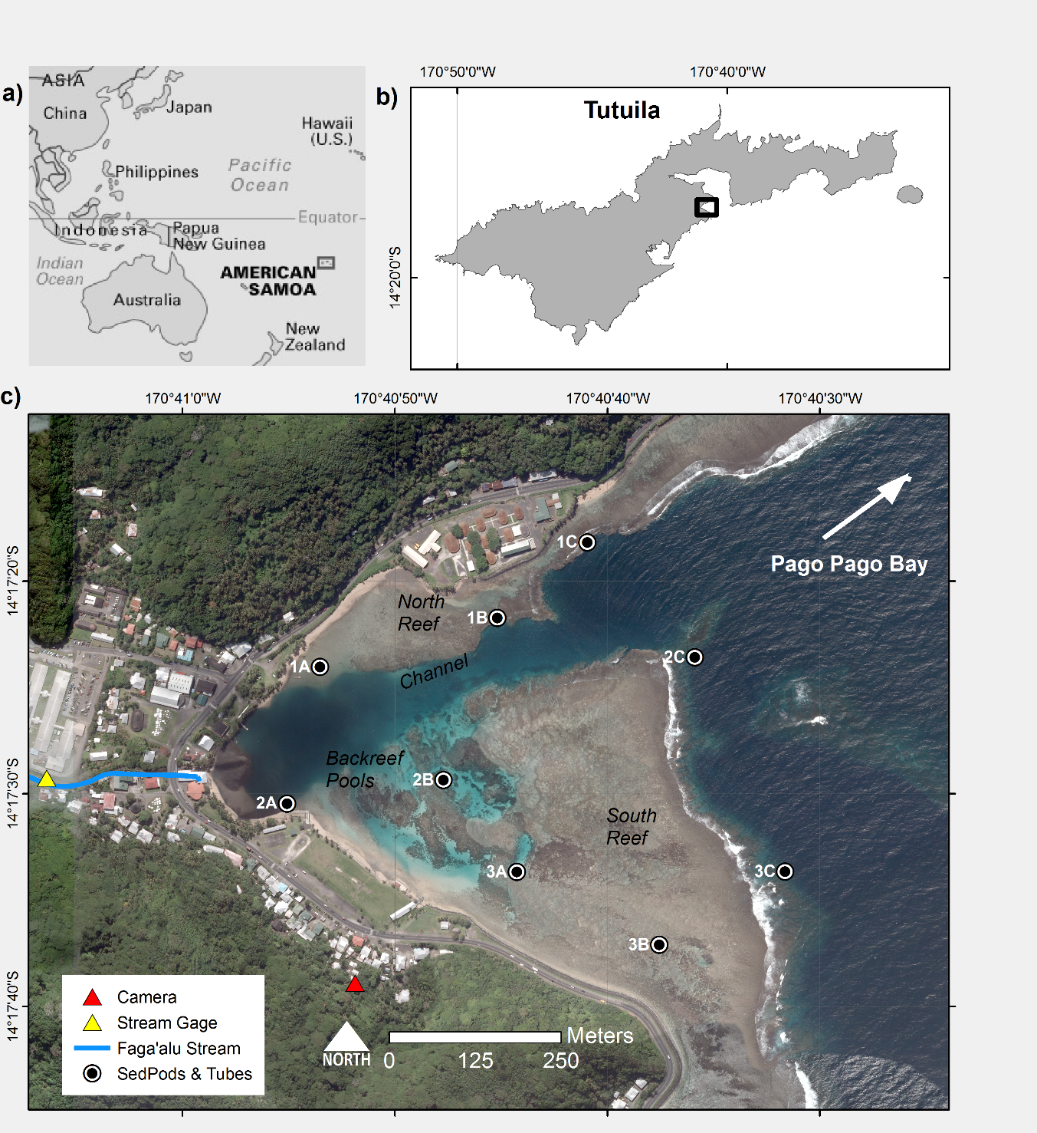

Figure 1. Maps of the study area and instrumentation in Faga'alu Bay. Sediment pods and sediment traps were deployed at nine locations for one year and collected quasi-monthly to measure sediment accumulation rates and composition. Suspended sediment yield from the watershed was measured at “Stream Gage.” Further details on SSY measurements and modeling can be found in (Messina and Biggs, *in press*). A time-lapse camera was installed at “Camera” to record images of transient sediment plumes during storms.

## Figure 2 Pictures of sediment traps



Figure 2. Pictures of the sediment traps and sediment pods at high tide. a-b) At Site 3A in an area of branching coral rubble, approximately 2m depth c) Capping the sediment pod for retrieval at Site 1C, approx. 10m depth d) At Site 1B, the surrounding area is mixed terrigenous and carbonate benthic sediment.

## Figure 3 SSY and Waves

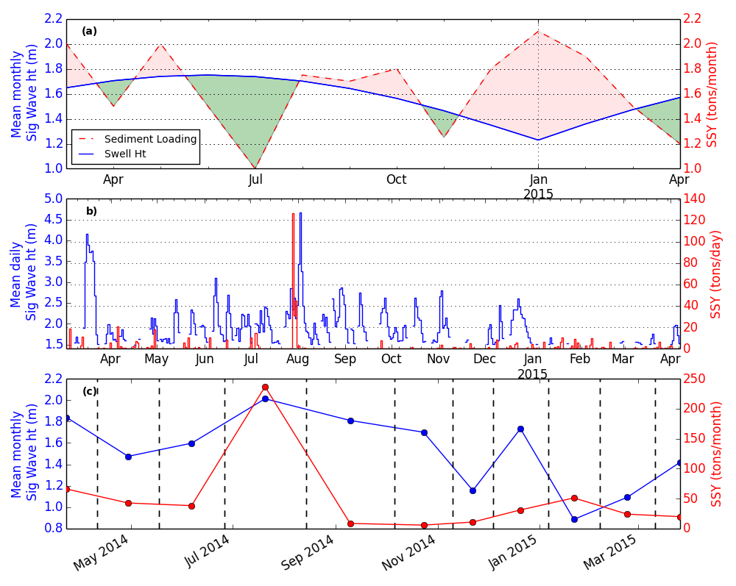

Figure 3. a) Hypothetical phasing of monthly sediment loading from the watershed and offshore wave height. Red shaded areas indicate a time of net terrigenous sediment accumulation and green shaded areas indicate a time of net terrigenous sediment removal and resuspension of marine-derived sediment, b) Mean daily significant wave height (m) exceeding 1.5 m from the NOAA WaveWatch III Samoa Regional Model and total daily Suspended Sediment Yield (SSY) (tons), and c) Mean significant wave height (m) and total SSY during deployment periods (dashed lines indicate sample collection dates).

## Figure 4 Time lapse of sediment plume

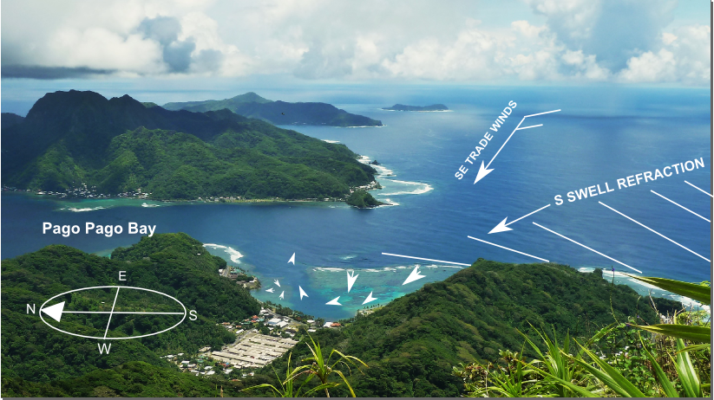

Camera

View

a)

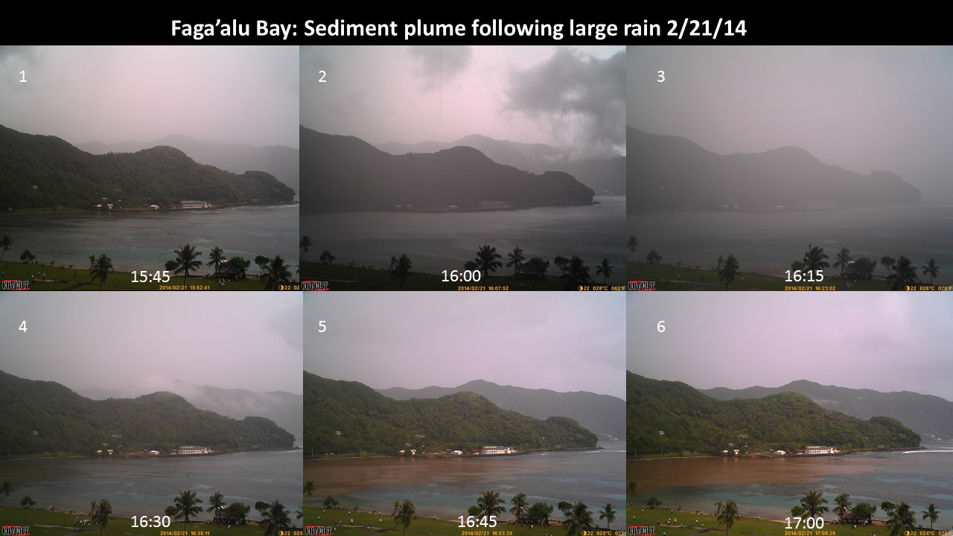

Channel

Sediment plume deflected over North reef and channel

North reef

South reef

Stream outlet

b)

Figure 4. a) Illustration of dominant wind and wave-forcing, and resulting water flow patterns b) Time series of sediment plume following a brief but intense rainfall. In frame 1 the Bay is clear of any sediment plume but following a short burst of rainfall in frame 2 and 3, a sediment plume is discharged from the stream outlet (frames 4-6) where it is deflected away from the South reef, over the North reef and channel, and out to sea. Later frames showed the same spatial pattern, and an apparent diminishing of sediment concentrations over the northern reef.

## Figure 5 Mean accumulation and benthic composition

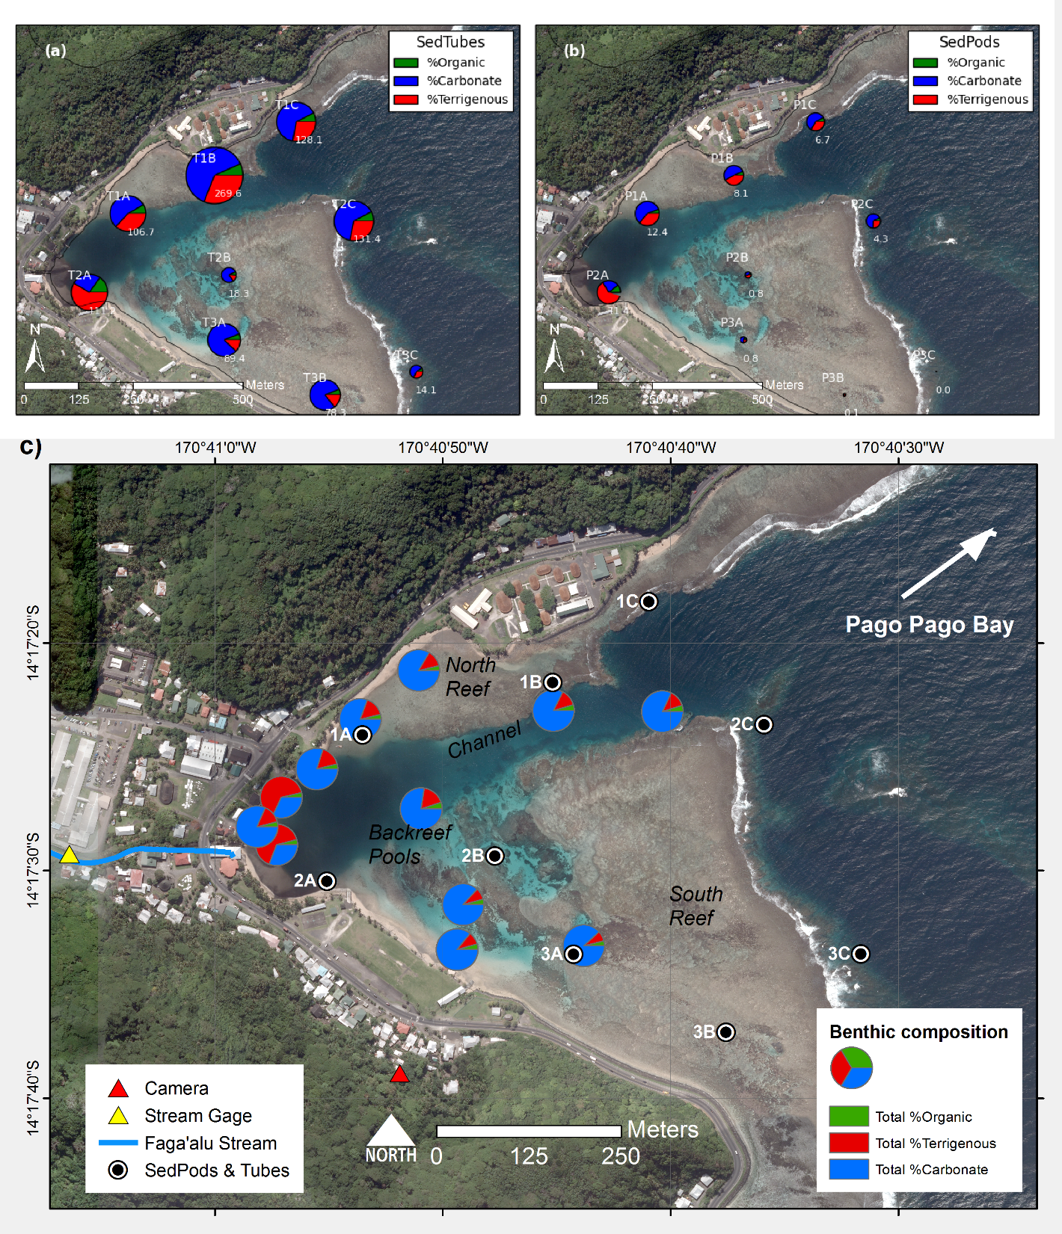

Figure 5. Mean accumulation rate (g m-2 d-1) and composition in a) sediment traps and b) sediment pods. c) Benthic sediment composition. Note: Subplot scales are different for visualization purposes, can’t compare sizes of charts, hence numbers included.

## Figure 6 Mean accumulation time series-sediment pods

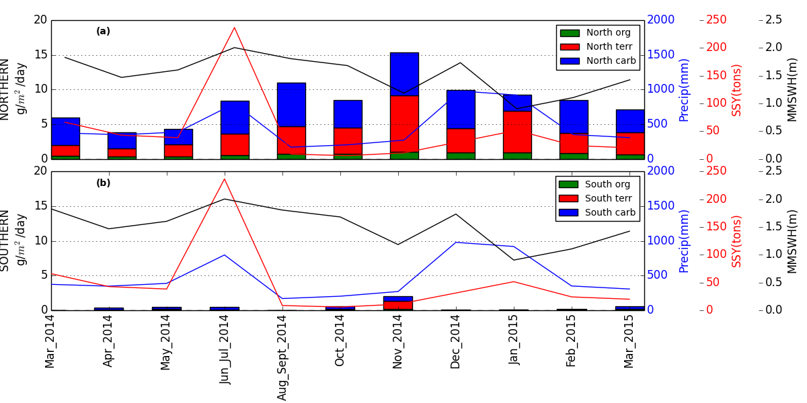

Figure 6. Mean sediment accumulation on sediment pods during the study period over the a) north reef including sites 1A, 1B, 1C, 2A, 2C, and b) south reefs including sites 2B, 3A, 3B, 3C.

## Figure 7 Mean accumulation time series-sediment traps

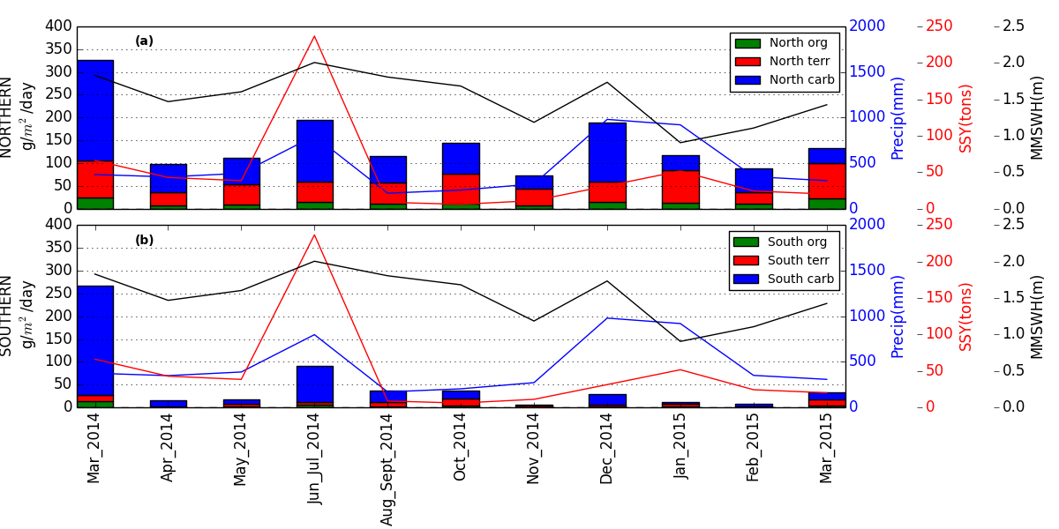

Figure 7. Mean sediment accumulation in sediment traps during the study period over the a) north reef including sites 1A, 1B, 1C, 2A, 2C, and b) south reefs including sites 2B, 3A, 3B, 3C

## Figure 8 Sediment accumulation time series- sediment pods

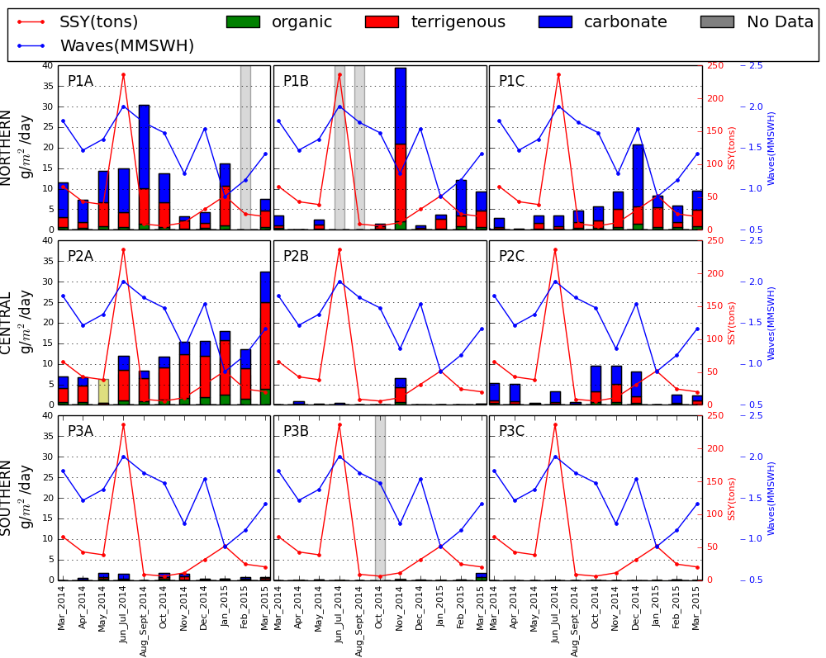

Figure 8. Time series' of sediment accumulation and composition on sediment pods at nine sediment trap locations in Faga'alu Bay, related to suspended-sediment yield from the watershed (SSY) and mean significant wave height (m). “P” indicates sediment “pod” and location ID’s (ex. 2A) correspond to sites in Figure 1.

## Figure 9 Sediment accumulation time series- sediment traps

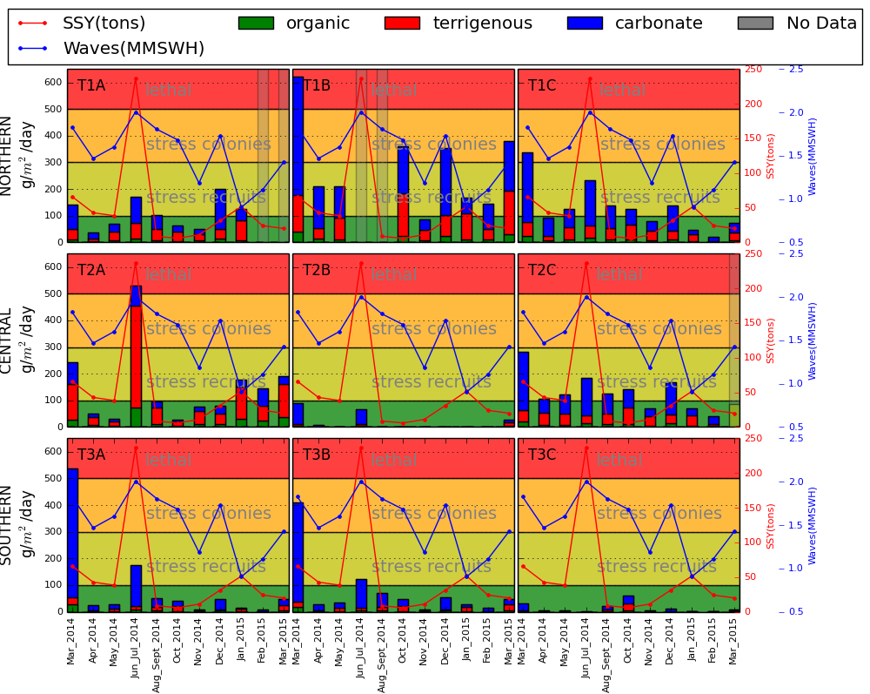

Figure 9. Time series' of sediment accumulation in sediment traps and composition at nine sediment trap locations in Faga'alu Bay, related to suspended sediment yield from the watershed (SSY) and mean significant wave height (m). “T” indicates sediment “trap” and location ID’s (ex. 2A) correspond to sites in Figure 1. Coral health thresholds related to sediment accumulation in tubes from *Erftemeijer et al. (2012)* are included for reference only.

## Figure 10 Correlations

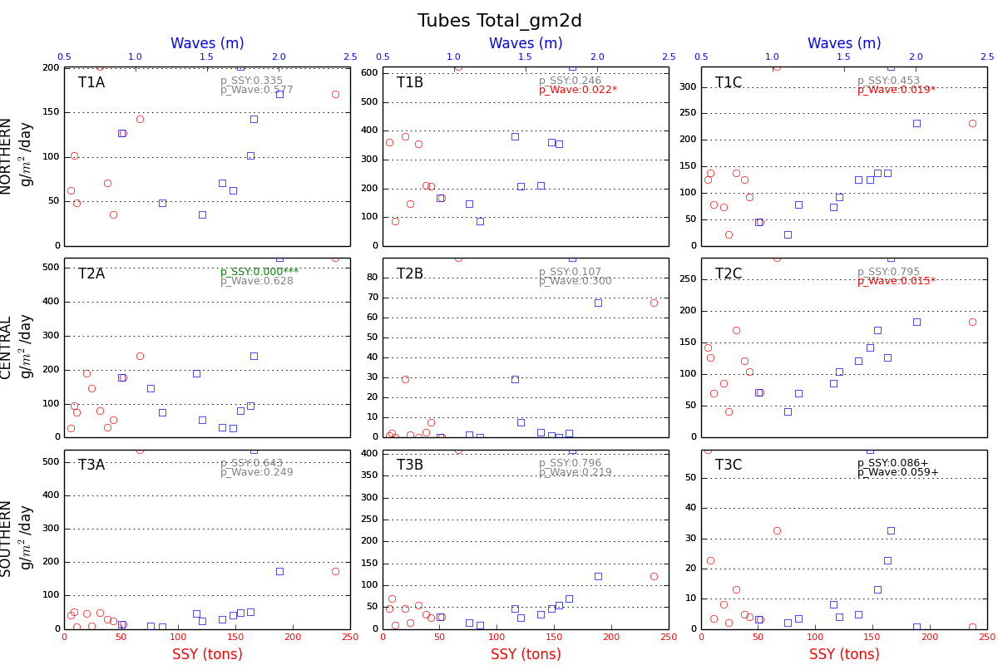

Figure 10. Correlations between total sediment accumulations in sediment traps vs SSY, mean wave height*. P-*values are for multiple regression

# References

Basher L, Hicks D, Clapp B, Hewitt T (2011) Sediment yield response to large storm events and forest harvesting, Motueka River, New Zealand. New Zeal. J. Mar. Freshw. Res. 45:333–356

Bégin C, Brooks G, Larson R a., Dragićević S, Ramos Scharrón CE, Coté IM (2014) Increased sediment loads over coral reefs in Saint Lucia in relation to land use change in contributing watersheds. Ocean Coast. Manag. 95:35–45

Bellwood DR, Fulton CJ (2008) Sediment-mediated suppression of herbivory on coral reefs: Decreasing resilience to rising sea-levels and climate change? Limnol. Oceanogr. 53:2695–2701

Bever AJ, McNinch JE, Harris CK (2011) Hydrodynamics and sediment-transport in the nearshore of Poverty Bay, New Zealand: Observations of nearshore sediment segregation and oceanic storms. Cont. Shelf Res. 31:507–526

Bothner MH, Reynolds RL, Casso MA, Storlazzi CD, Field ME (2006) Quantity, composition, and source of sediment collected in sediment traps along the fringing coral reef off Molokai, Hawaii. Mar. Pollut. Bull. 52:1034–47

Brooks G, Devine B, Larson R, Rood B (2007) Sedimentary Development of Coral Bay , St . John , USVI : A Shift From Natural to Anthropogenic Influences. Caribb. J. Sci. 43:226–243

Browne NK., Smithers SG., Perry CT., Ridd PV. (2012) A Field-Based technique for measuring sediment flux on coral reefs: Application to turbid reefs on the great barrier reef. J. Coast. Res. 28:1247–1262

Cochran SA, Gibbs AE, D’Antonio NL, Storlazzi CD (2016) Benthic habitat map of U.S. Coral Reef Task Force Faga‘alu Bay priority study area, Tutuila, American Samoa: U.S. Geological Survey Open-File Rport 2016-XXXX, XX.

Craig P (2009) Natural History Guide to American Samoa. National Park of American Samoa, Pago Pago, American Samoa

Dames & Moore (1981) Hydrologic Investigation of Surface Water for Water Supply and Hydropower. 63

DeMartini E, Jokiel P, Beets J, Stender Y, Storlazzi C, Minton D, Conklin E (2013) Terrigenous sediment impact on coral recruitment and growth affects the use of coral habitat by recruit parrotfishes (F. Scaridae). J. Coast. Conserv. 17:417–429

Draut AE, Bothner MH, Field ME, Reynolds RL, Cochran, S.A.Logan JB, Storlazzi CD, Berg CJ (2009) Supply and dispersal of flood sediment from a steep, tropical watershed: Hanalei Bay, Kaua’i, Hawai'i, USA. Geol. Soc. Am. Bull. 121:574–585

Duvert C, Nord G, Gratiot N, Navratil O, Nadal-Romero E, Mathys N, Némery J, Regüés D, García-Ruiz JM, Gallart F, Esteves M (2012) Towards prediction of suspended sediment yield from peak discharge in small erodible mountainous catchments (0.45–22km2) of France, Mexico and Spain. J. Hydrol. 454-455:42–55

Erftemeijer PL a, Riegl B, Hoeksema BW, Todd P a. (2012) Environmental impacts of dredging and other sediment disturbances on corals: A review. Mar. Pollut. Bull. 64:1737–1765

Fabricius KE (2005) Effects of terrestrial runoff on the ecology of corals and coral reefs: review and synthesis. Mar. Pollut. Bull. 50:125–46

Fabricius KE, De’ath G, Humphrey C, Zagorskis I, Schaffelke B (2012) Intra-annual variation in turbidity in response to terrestrial runoff on near-shore coral reefs of the Great Barrier Reef. Estuar. Coast. Shelf Sci. 1–9

Feagaimaalii-Luamanu J (2016) High surf generated by TC Victor washes over roads and property. Samoa News

Field ME, Chezar H, Storlazzi CD (2012) SedPods: a low-cost coral proxy for measuring net sedimentation. Coral Reefs 1–5

Gray SC, Sears W, Kolupski ML, Hastings ZC, Przyuski NW, Fox MD, Degrood A (2012) Factors affecting land-based sedimentation in coastal bays, US Virgin Islands. 9–13

Heiri O, Lotter AF, Lemcke G (2001) Loss on ignition as a method for estimating organic and carbonate content in sediments : reproducibility and comparability of results. J. Paleolimnol. 25:101–110

Hettler J, Irion G, Lehmann B (1997) Environmental impact of mining waste disposal on a tropical lowland river system: a case study on the Ok Tedi Mine, Papua New Guinea. Miner. Depos. 32:280–291

Hoitink AJF, Hoekstra P (2003) Hydrodynamic control of the supply of reworked terrigenous sediment to coral reefs in the Bay of Banten (NW Java, Indonesia). Estuar. Coast. Shelf Sci. 58:743–755

Holst-Rice S, Messina A, Biggs TW, Vargas-Angel B, Whitall D (2016) Baseline Assessment of Fagaʻalu Watershed: A Ridge to Reef Assessment in Support of Sediment Reduction Activities and Future Evaluation of their Success.

Jokiel PL, Rodgers KS, Storlazzi CD, Field ME, Lager C V., Lager D (2014) Response of reef corals on a fringing reef flat to elevated suspended-sediment concentrations: Molokaʻi, Hawaiʻi. PeerJ 2:

Jones R, Bessell-Browne P, Fisher R, Klonowski W, Slivkoff M (2015) Assessing the impacts of sediments from dredging on corals. Mar. Pollut. Bull.

Klein CJ, Jupiter SD, Selig ER, Watts ME, Halpern BS, Kamal M, Roelfsema C, Possingham HP (2012) Forest conservation delivers highly variable coral reef conservation outcomes. Ecol. Appl. 22:1246–56

McDougall I (1985) Age and Evolution of the Volcanoes of Tutuila American Samoa. Pacific Sci. 39:311–320

Meng P-J, Lee H-J, Wang J-T, Chen C-C, Lin H-J, Tew KS, Hsieh W-J (2008) A long-term survey on anthropogenic impacts to the water quality of coral reefs, southern Taiwan. Environ. Pollut. 156:67–75

Messina AT, Biggs TW (2016) Contributions of human activities to suspended sediment yield during storm events from a small, steep, tropical watershed. J. Hydrol. XX:XX

Messina AT, Storlazzi CD, Cheriton O, Biggs TW Eulerian and Lagrangian measurements of flow and residence time on a fringing reef flat embayment, American Samoa.

Militello A, Scheffner NW, Thompson EF (2003) Hurrican-Induced Stage-Frequency Relationships for the Territory of American Samoa. USACOE Technical Report CHL-98-33.

Muzuka ANN, Dubi AM, Muhando CA, Shaghude YW (2010) Impact of hydrographic parameters and seasonal variation in sediment fluxes on coral status at Chumbe and Bawe reefs, Zanzibar, Tanzania. Estuar. Coast. Shelf Sci. 89:137–144

Nakamura S (1984) Soil Survey of American Samoa.

PACIOOS PIOOS (2016) WaveWatch III Samoa Regional Model. http://oos.soest.hawaii.edu/pacioos/

Perreault J (2010) Development of a Water Budget in a Tropical Setting Accounting for Mountain Front Recharge: Tutuila, American Samoa. University of Hawai’i

Pomeroy AWM, Lowe RJ, Ghisalberti M, Storlazzi CD, Cuttler M, Symonds G (2015) Mechanics of Sediment Suspension and Transport Within a Fringing Reef. 1–14

Ramos-Scharrón CE, Macdonald LH (2007) Measurement and prediction of natural and anthropogenic sediment sources, St. John, US Virgin Islands. Catena 71:250–266

Rangel-Buitrago N, Anfuso G, Phillips M, Thomas T, Alvarez O, Forero M (2014) Characterization of wave climate and extreme events into the SW Spanish and Wales coasts as a first step to define their wave energy potential. J. Coast. Res. 70:314–319

Ryan KE, Walsh JP, Corbett DR, Winter a (2008) A record of recent change in terrestrial sedimentation in a coral-reef environment, La Parguera, Puerto Rico: a response to coastal development? Mar. Pollut. Bull. 56:1177–83

Santisteban JI, Mediavilla R, Lopez-Pamo E, Dabrio CJ, Zapata MBR, Garcia MJG, Castano S, Martínez-Alfaro PE (2004) Loss on ignition: a qualitative or quantitative method for organic matter and carbonate mineral content in sediments? J. Paleolimnol. 32:287–299

Seymour RJ (2011) Evidence for Changes to the Northeast Pacific Wave Climate. J. Coast. Res. 27:194–201

Storlazzi CD, Field ME, Bothner MH (2011) The use (and misuse) of sediment traps in coral reef environments: theory, observations, and suggested protocols. Coral Reefs 30:23–38

Storlazzi CD, Field ME, Bothner MH, Presto MK, Draut AE (2009) Sedimentation processes in a coral reef embayment: Hanalei Bay, Kauai. Mar. Geol. 264:140–151

Storlazzi CD, Norris BK, Rosenberger KJ (2015) The influence of grain size, grain color, and suspended-sediment concentration on light attenuation: Why fine-grained terrestrial sediment is bad for coral reef ecosystems. Coral Reefs 34:967–975

Teneva LT, Mcmanus MA, Jerolmon C, Neuheimer AB, Clark SJ, Walker G, Kaho K, Shimabukuro E, Ostrander C, Kittinger JN (2016) Understanding Reef Flat Sediment Regimes and Hydrodynamics can Inform Erosion Mitigation on Land. Collabra 2:1–12

Thomas S, Ridd P (2005) Field assessment of innovative sensor for monitoring of sediment accumulation at inshore coral reefs. Mar. Pollut. Bull. 51:470–80

Thompson EF, Demirbilek Z (2002) Wave Response, Pago Pago Harbor, Island of Tutuila, Territory of American Samoa. USACOE Coastal and Hydraulics Laboratory ERDC/CHL TR-02-20.

Tonkin & Taylor International Ltd. (1989) Hydropower feasibility studies interim report - Phase 1. Ref: 97/10163.

Vetter O (2013) Inter-Disciplinary Study of Flow Dynamics and Sedimentation Effects on Coral Colonies in Faga’alu Bay, American Samoa: Oceanographic Investigation Summary. NOAA CRCP Project #417.

Victor S, Neth L, Golbuu Y, Wolanski E, Richmond RH (2006) Sedimentation in mangroves and coral reefs in a wet tropical island, Pohnpei, Micronesia. Estuar. Coast. Shelf Sci. 66:409–416

Warrick JA, Mertes LAK, Washburn L, Siegel DA (2004) Dispersal forcing of southern California river plumes, based on field and remote sensing observations. Geo-Marine Lett. 24:46–52

Weber M, de Beer D, Lott C, Polerecky L, Kohls K, Abed RMM, Ferdelman TG, Fabricius KE (2012) Mechanisms of damage to corals exposed to sedimentation. Proc. Natl. Acad. Sci. 109:E1558–E1567

Wolanski E, Fabricius KE, Spagnol S, Brinkman R (2005) Fine sediment budget on an inner-shelf coral-fringed island, Great Barrier Reef of Australia. Estuar. Coast. Shelf Sci. 65:153–158

Wolanski E, Richmond RH, Davis G, Bonito V (2003) Water and fine sediment dynamics in transient river plumes in a small, reef-fringed bay, Guam. Estuar. Coast. Shelf Sci. 56:1029–1040

Wong M (1996) Analysis of Streamflow Characteristics for Streams on the Island of Tutuila, American Samoa. U.S. Geological Survey Water-Resources Investigations Report 95-4185.